# Assignment 1

## Part 1

## Create a Java program that achieves the following:

1. Create a file ***Question1.java***.
2. Ask the user for their name.
3. Ask the user for their surname.
4. Print their initials: Extract the first character of the name and surname, capitalize each extracted character and print their initials (separated with a full-stop).
5. **Hint: Use JavaDocs**
6. Start with this class:
7. 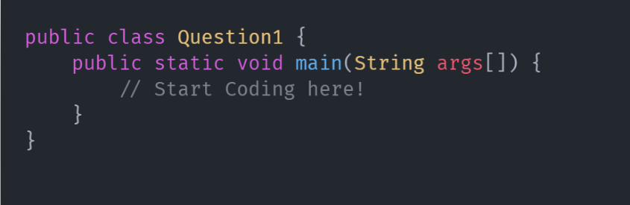
8. Example Output:
9. A close up of a computer screen

   Description automatically generated
10. Add your Name, Surname, and student number at the beginning of the Java file as a Java comment.
11. Create a new Folder called ***Assignment 1*** Save your file as ***Question1.java***.

## Part 2

1. Create a new file called ***Question2.java*** and save it in the same folder.
2. Add a constructor method to the Question2 class that takes a **String message** as input and saves it to a private class field: **message**.
3. Add a function called printMessage() that takes zero arguments, returns void and prints the message to the console.
4. Add the main function where you will create 2 instances of the Question2 class, each with different values.
5. Finally, call the toString method on each of the instances and print their results to the console.
6. Add your Name, Surname, and student number at the beginning of the Java file as a Java comment.
7. Save your files. Zip the Assignment 1 folder and submit to eFundi.

## Rubric

|  |  |
| --- | --- |
| **Requirement** | Mark |
| Name and Student Number commented at the top of each file.  Files correctly named.  Folder zipped and submitted | 4 |
| **Question 1** |  |
| String methods used | 2 |
| Scanner correctly imported and implemented | 2 |
| Correct Output | 2 |
| **Question 2** |  |
| Correct class field message | 2 |
| Correct constructor | 2 |
| Correct printMessage method | 2 |
| 2 instances | 2 |
| Different messages printed | 2 |
| **Total** | **20** |